**RocksDB VS LevelDB benchmark**

Write a single key value pair

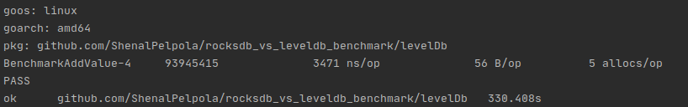

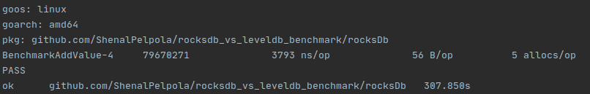

Write a 10 key value pairs

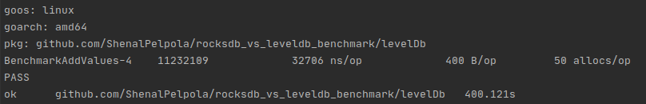

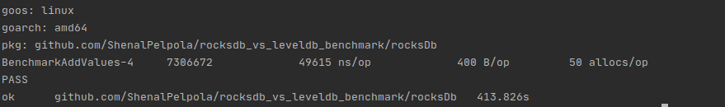

Write a 100 key value pairs

***Figure 7: LevelDB read 1000 key value pairs***

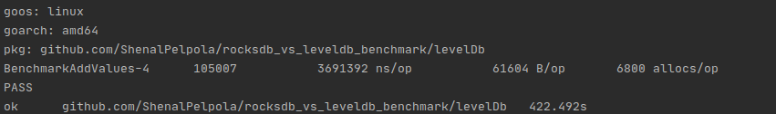

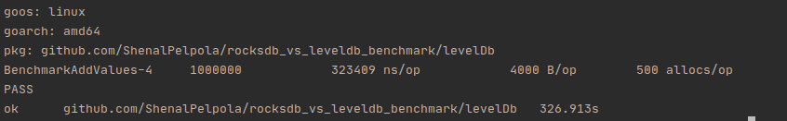

Write a 1000 key value pairs

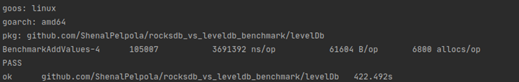

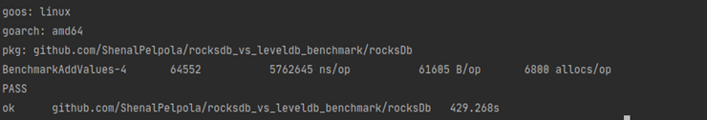

Read single key value pair

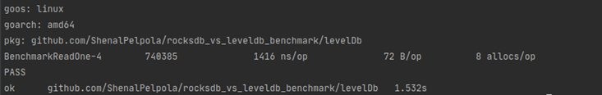

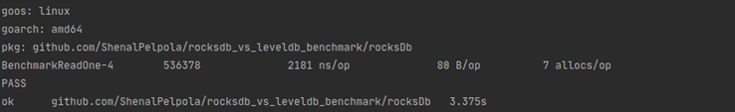

Read 10 key value pairs





Read 100 key value pairs

***Figure 13: LevelDB write 100 key value pairs***





***Figure 14: RocksDB write 100 key value pairs***

Read 1000 key value pairs





**Summary**

|  |  |  |
| --- | --- | --- |
|  | **RocksDB** | **LevelDB** |
| Write a single key value pair | 3798 ns/op | 3471 ns/op |
| Write 10 key value pairs | 49615 ns/op | 32706 ns/op |
| Write 100 key value pairs | 502061 ns/op | 323409 ns/op |
| Write 1000 key value pairs | 5762645 ns/op | 3691392 ns/op |
| Read single key value pair | 2181 ns/op | 1416 ns/op |
| Read 10 key value pairs | 397990 ns/op | 347601 ns/op |
| Read 100 key value pairs | 3959958 ns/op | 3607663 ns/op |
| Read 1000 key value pairs | 37421335 ns/op | 31843571 ns/op |